Dooms Day by Jaiden – Class 2
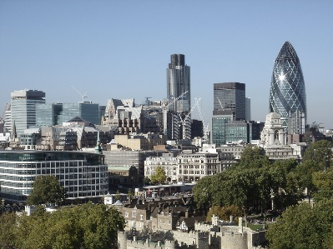
It was a good day in Pen City, but Bob knew something would happen – he saw it in a dream. He told all the city what could happen but they didn’t believe him apart from his best friend Thomas.

The next day the sky was gloomy with a hint of red. That made Bob scared that the dream was really going to be happening – but no-one would listen to him. They thought that they were safe in their houses.

But they were wrong.
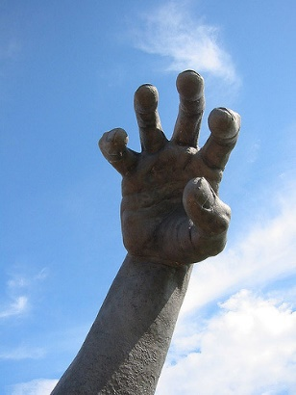
A big, massive hand was coming down towards Pen City and, as Bob looked up, he saw a huge giant who was crying. Bob asked why he was upset and the giant told Bob that the other giants didn’t want to be his friends. They made fun of him because he was smaller than them.

Bob told the giant that he would be his friend and that it is ok to be different from everyone else.

The giant smiled at Bob and said thank you for being my friend. The giant went home.
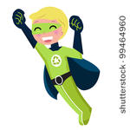
The town people were all cheering and calling Bob a hero, saying sorry for not believing him.

Bob said to everyone to never judge a book by its cover, as like the giant, everyone judged him because he was different and that it’s not being nice.

