A Doggie’s Adventure by Aaliyah – Class 3

There lived 3 doggies called Bella, Pixie and, last and not least, Peppa. They were so kind. They had a mum who bought them. She was very kind. She helped them a lot – she was called Aaliyah. They looked very cute, but they could be shy.

For their dinner, Aaliyah gives them dog food and if they eat it all, they might get a big, brown biscuit. When the dogs are feeling sad, Aaliyah plays with them to cheer them up.

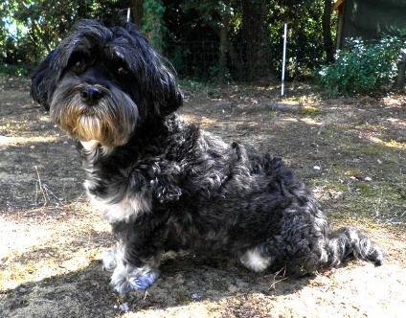
Out of the darkness, pooped their shining, blue eyes. Aaliyah had an idea. She said to the dogs, “Want to go out for walkies?”

The dogs barked and off they all set.

Aaliyah found a long, zigzag twig. She threw it and all of the dogs fetched and bought it back. She did it over and over and eventually they got tired so they headed home.
Aaliyah got her pink dressing gown and snuggled up on the comfy, black sofa with all of the cute, shy dogs.

The dogs are very shy because they’ve never seen anybody else, just Aaliyah. Eventually, they all fell asleep hugging.

